C:\Users\Emine Nur Gülsu\Desktop\ddsds.jpg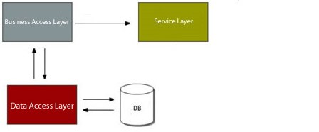**Uygulama Mimari Diyagramı**